OOP Lab 6
6.1 Develop a super class „Animal‟ that takes name of animal as an argument to default constructor. The super class should be implemented in such a way that it becomes mandatory for all child classes to implement „talk‟ method if they want to instantiate the object. The child classes (cat and dog) should return the relevant voices through „talk‟ method

Source code
class Animal:
def __init__(self, name):
n = name
print("I am ", n)

def talk(self):
print("I can talk")

class cat(Animal):
def talk(self):
print("Meao!")
super().talk()

class dog(Animal):
def talk(self):
print("Bark!")
super().talk()

name = input("Enter pet name:")
someone = dog(name)
someone.talk()

name = input("Enter pet name:")
someone = cat(name)
someone.talk()

Output
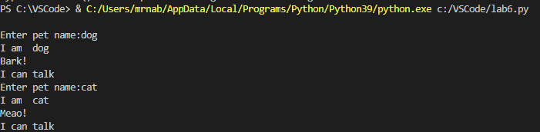

6.2 Develop a super class „Person‟. The super class has a method „ticket_price‟ which should be implemented in such a way that it becomes mandatory for all child classes to implement „ticket_price‟ method if they want to instantiate the object. The child classes (Employed_person and student) should return the relevant ticket prices after concession applicable to these categories.

Source code
class Person:
price = 0
def Ticket_price(self):
print("The original ticket price was ", Person.price)

class Employed_person(Person):
def Ticket_price(self):
dp = Person.price * 0.5
price = Person.price - dp
print("\nThe price of the ticket after 50% discount for employee is: ", price)
super().Ticket_price()

class student(Person):
def Ticket_price(self):
dp = Person.price * 0.2
price = Person.price - dp
print("\nThe price of the ticket after 20% discount for student is: ", price)
super().Ticket_price()

Person.price = input("Enter the price of the ticket: ")

Person.price = float(Person.price)

p = Employed_person()
p.Ticket_price()

p = student()
p.Ticket_price()

Output
